Tami Franklin

Author • Speaker • Coach

**Short Bio**

Tami Franklin is an author, speaker, and transformational coach whose life and message reflect the redemptive power of God. Through her debut book, *Un-Masked, Un-Broken, Healed & Set Free*, Tami shares her real-life journey through trauma, grief, and restoration. As the founder of **House of Hope & Healing**, she equips others to reclaim their voice, walk in healing, and live with purpose and **G.O.T. Foundation, Inc.**, a nonprofit dedicated to global missions and outreach. Her story is a testimony to God’s faithfulness, even in the deepest valleys.

### Long ****Bio** Tami Franklin** is a woman of resilience, faith, and fierce hope. A published author, transformational coach, and speaker, Tami’s life is a living testimony to God’s redemptive power after decades marked by childhood trauma, abuse, the tragic loss of two children, and spiritual battles that nearly silenced her. Yet through it all, she emerged not only healed, but empowered.

In her powerful debut book, Un-Masked, Un-Broken, Healed & Set Free, Tami invites readers into the sacred spaces of her personal healing journey. With raw vulnerability and spiritual insight, she helps others find courage in their own brokenness and reminds them that God’s plan is always restoration.

As the founder of House of Hope & Healing, LLC and G.O.T. Foundation, Inc., she serves individuals navigating life’s hardest valleys, helping them discover healing and freedom in Christ through programs rooted in faith, restoration, and transformation. Her coaching and retreat offerings are preparing to launch soon as part of her ongoing mission to help others reclaim their voice and walk boldly in healing.

Through her podcast, Keep Healing Sis, and a growing digital ministry, Tami offers encouragement, truth and grace to those navigating hard places. She is currently preparing for her Fall 2025 book tour and speaking engagements, committed to reaching those who feel unseen, unheard, or unloved.

Tami’s voice is a balm for the wounded and a battle cry for those ready to rise.

### Book Overview:

**Title:** Un-Masked, Un-Broken, Healed & Set Free  
**Author:** Tami Franklin  
**Tagline (optional):** What broke you doesn’t have the final say—God does.

**Short Blurb:**  
This is more than a book—it’s an invitation into truth, healing, and deep restoration. In Un-Masked, Un-Broken, Healed & Set Free, Tami Franklin shares her raw and redemptive journey through trauma, loss, betrayal, and spiritual warfare to showcase the power of God’s healing love.

**Full Description:**  
Tami Franklin spent decades surviving what others could barely imagine, childhood trauma, abuse, grief, and the tragic loss of two of her children. But through every heartbreak and hard season, God was writing a greater story. In this debut memoir, Tami peels back the layers of pain with unflinching honesty, revealing the slow, sacred work of healing that only God can do.

Each chapter offers not just a glimpse into her past, but an invitation into the reader’s own healing. This book is for those who’ve ever felt silenced, stuck, shattered, or spiritually exhausted. It’s a roadmap to redemption, showing that no matter how broken your story feels, God can still bring beauty from the ashes.

**Key Themes:**

* Childhood trauma and emotional healing
* Faith and spiritual restoration
* Grief after child loss
* Breaking cycles of abuse
* Identity, forgiveness, and freedom
* Redemption and reclaiming purpose

**Target Audience:**  
This book is for anyone who has ever felt silenced by trauma, crushed by grief, or stuck in a season they didn’t choose. Whether walking through heartbreak, betrayal, loss, or the long road of healing, *Un-Masked, Un-Broken, Healed & Set Free* offers hope for the hurting and strength for the weary. It speaks to **anyone ready to reclaim their voice**, rediscover their purpose, and believe again that God still has more for their lives.

**Publishing Details:**

* **Release Date:** October 6, 2025
* **Retail Price:** $18.99 (Paperback)
* **Formats:** Paperback, eBook (Kindle and EPUB)
* **ISBN:** 979-8-218-26913-5

**✨ Author Q&A: Tami Franklin**

**Q1: What inspired you to write *Un-Masked, Un-Broken, Healed & Set Free*?**  
**A:** I wrote this book because I couldn’t stay silent any longer. For years, I carried the weight of trauma, loss, and shame, believing healing was for everyone else. But God met me in the ruins and taught me that restoration isn’t just possible, it’s His promise. This book is my testimony and my offering to others who feel unseen or stuck in their pain. If my story can help just one person believe again, it was worth writing.

**Q2: Who did you write this book for?**

I wrote it for the woman crying in secret, the man battling demons and silently at war, the parent who’s lost a child, the survivor who’s still trying to piece their life back together. I wrote it for anyone who’s ever questioned their very existence or wondered if healing was possible for them. This book is for those ready to walk out of survival mode and into a glorious, divine freedom.

**Q3: How did your faith impact your healing journey and this book?**

A: My faith is the foundation of everything. I’ve walked through more than I ever imagined possible, childhood trauma, mental, physical and emotional abuse, unspeakable tragedies, the earthly deaths of two of my children, and deep spiritual warfare. But it was the presence of God in the darkest places that taught me healing isn’t about perfection, it’s about surrender. Every chapter of this book was written with prayer, tears, extreme warfare against the enemy that tried to silence me and the reminder that God doesn’t waste anything, especially not our pain. Even that is holy ground.

**Q4: What message do you want readers to walk away with?**  
**A:** That what broke you doesn’t have the final say, God does. I want readers to know that no matter how shattered their life may feel, God is still writing their story. Healing is possible. Redemption is real. And your voice, your story, and your purpose still matter.

**Q5: What’s next for you?**  
**A:** I’m preparing for my Fall 2025 book tour, launching my podcast Keep Healing Sis, and continuing to expand House of Hope & Healing and the G.O.T. Foundation. Everything I do is rooted in helping others heal forward and live free. I believe the best chapters of my life, and the lives of those I’m called to serve, are just beginning.

### Speaker Topics

### 1. Un-Masked, Un-Broken, Healed & Set Free

**Topic:** Breaking Free from Shame and Silence  
**Description:** Based on her debut book, Tami shares how unmasking the pain of her past led to healing, wholeness, and the freedom to live authentically. A raw, powerful message for anyone still wearing emotional armor.

**2. When Grief Won’t Let Go**

**Topic:** Living Between Two Worlds  
**Description:** As a bereaved parent who has lost two children, Tami offers a deeply compassionate message about grief, legacy, and navigating the tension of living while healing. This session reminds the grieving: you’re not alone, and healing is holy ground.

**3. What Broke You Doesn’t Have the Final Say**

**Topic:** Redemption in the Aftermath of Trauma  
**Description:** Tami reveals how the darkest seasons of trauma and betrayal became the soil for her greatest spiritual transformation. A message of hope for anyone who feels like their story is beyond repair.

**4. Healing Forward**

**Topic:** Reclaiming Your Voice and Your Life  
**Description:** This empowering session speaks to survivors ready to stop reliving the pain and start rewriting their future. Learn how to move from stuck to surrendered, from broken to becoming.

**5. From Surviving to Surrendered**

**Topic:** A Faith-Filled Path to Inner Healing  
**Description:** Tami teaches how surrender, is the key to deep healing. Blending scripture, lived experience, and prophetic encouragement, this message helps audiences shift from performance to divine peace.

**6. A Seat for Every Story**

**Topic:** Creating Safe Spaces for Healing Conversations  
**Description:** Inspired by *The Hope Table* and *Chapters of Healing: By the Fireside,* this session explores the power of shared testimony and intentional community as a pathway to healing and connection.

**7. Daughter, You’re Still Called**

**Topic:** Rebuilding Faith After Church Hurt or Disappointment  
**Description:** For anyone who’s ever questioned their worth after spiritual betrayal or wondered if God still sees them, this message offers hope: the calling hasn’t changed, and their identity remains secure in the truth of who God says they are.

**8. Called to Heal What Tried to Kill You**

**Topic:** Walking Boldly in Your Assignment  
**Description:** Tami equips those called to ministry, leadership, or coaching to confront the very giants they once ran from. Because when God heals you, He also sends you.

### ****Book Overview:**** Un-Masked, Un-Broken, Healed & Set Free

**Un-Masked, Un-Broken, Healed & Set Free is not just a book, it’s a sacred invitation into truth, healing, and redemption.**

With raw transparency and unwavering faith, author and transformational coach **Tami Franklin** shares her real-life journey through childhood trauma, abuse, unspeakable grief, and deep spiritual warfare. For 36+ years, pain tried to silence her, but God had other plans.

Each chapter pulls back the curtain on survival, shame, and heartbreak, offering powerful glimpses into Tami’s healing process and the divine restoration that followed. Through personal testimony, prophetic insight, and practical encouragement, she invites readers into a healing journey of their own.

**This book is for:**

* The silent sufferer who’s been holding it all in
* The grieving parent questioning how to keep breathing
* The survivor unsure if healing is possible
* The faith-filled warrior exhausted from the battle

**Un-Masked, Un-Broken, Healed & Set Free** is a timely reminder that what broke you doesn’t have the final say, **God does.**

## **Media Features + Availability**

**Tami Franklin is media-ready and available for:**

* Podcast Interviews
* Faith-Based TV or Radio Segments
* Print & Digital Media Features
* Conference & Retreat Speaking Engagements
* Panel Discussions, Virtual Summits & Webinars
* Guest articles, devotionals, and blog features
* Book readings, launch collaborations, and community events

Tami speaks with honesty, authority, and Holy Spirit-led conviction on topics including healing from trauma, navigating grief and loss, overcoming spiritual warfare, finding purpose after pain, and the power of redemption. Her unique voice reaches audiences longing for truth, restoration, and the presence of God in their real-life struggles.

Rooted in a testimony of God’s faithfulness, she shares openly about her journey through childhood trauma, abuse, and the heartbreaking loss of two children. With raw transparency and unwavering hope, Tami reminds audiences that God can truly bring beauty from ashes and that healing and freedom are possible for every believer.

She welcomes collaboration with media outlets, ministries, podcasts, and platforms that align with her mission to help others heal forward and live free, equipping them to embrace transformation, redemption, and lasting freedom in Christ.

### Previously Featured On: *Coming Soon*

### Now Booking Fall 2025 + Beyond

### Tami Franklin is available for:

### Book Tour Events & Author Signings

* Church + Women’s Ministry Events
* Podcasts and Media Interviews
* Faith & Healing Conferences
* Nonprofit and Mission-Focused Panels

**Author Headshot**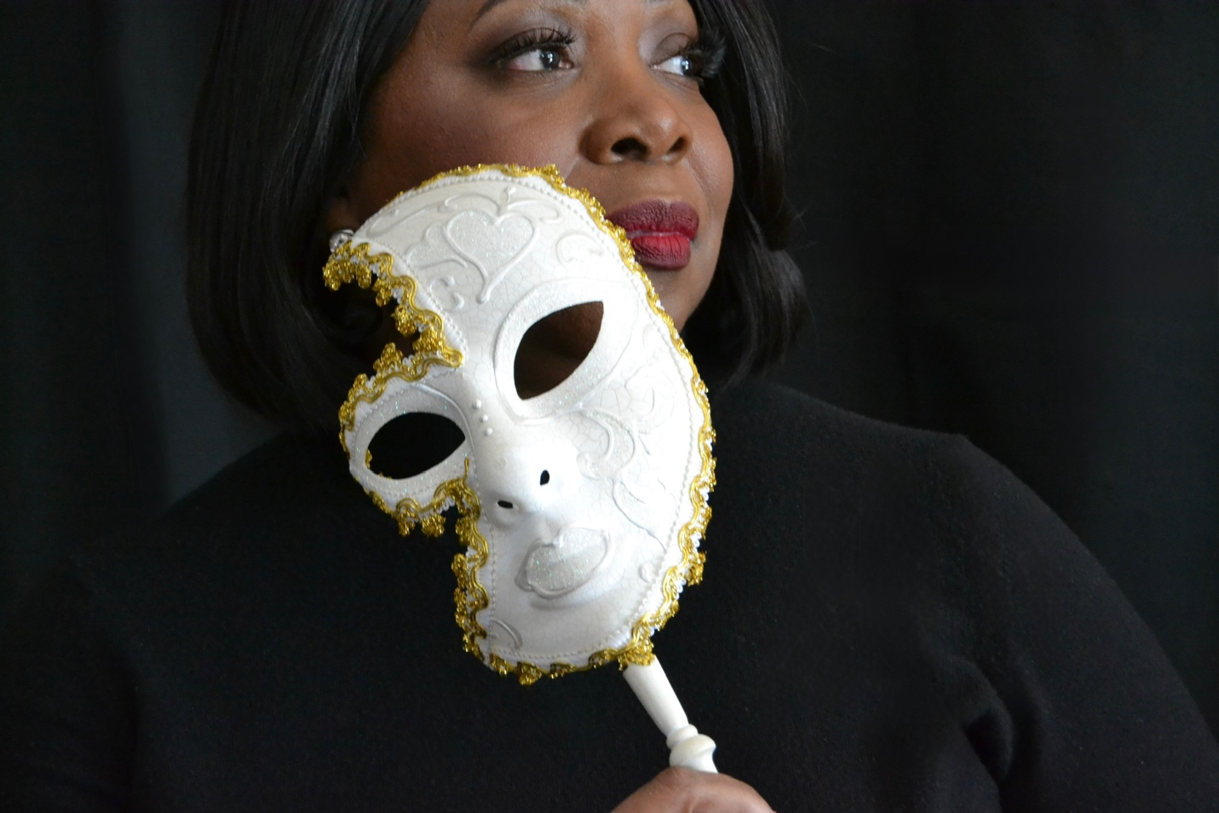

**✉️ Contact & Booking**To invite **Tami Franklin** to speak at your next event, appear on your platform, or collaborate on a media feature, please use the details below:

**Email:**  
[info@TamiFranklin.com](mailto:info@TamiFranklin.com)

**Coaching Booking Link:**  
<https://calendly.com/healhouse4you/coaching-consultation-session>

**🌐 Website:**  
[TamiFranklin.com](https://tamifranklin.com/)   
  
**🛍️ Merch Store:**  
*Coming Soon*

**☕ Support the Mission:**  
Buy Me a Coffee [www.buymeacoffee.com/FranklyT50](http://www.buymeacoffee.com/FranklyT50)

Tami reads every inquiry and looks forward to partnering with like-hearted platforms that create space for healing, truth, and transformation.